

MONTHLY REPORT

JANUARY 2023

SGS_DEP

**Managed Services**



Objective

Below report shows the comprehensive operation report for the ADDA tenant SGS DEP. The Report consists of Cloud Resource Utilization, Network Bandwidth Utilization, Alarm and Tickets handled by the Managed Services Team for Month 01 of 2023 (January).

# Cloud Resource Utilization - DEP

|  |  |
| --- | --- |
| G42 Cloud Services | Current  Resource Count |
| Elastic Cloud Server (ECS) PROD | 3 |
| Elastic Cloud Server (ECS) STG | 4 |
| Elastic Cloud Server (ECS) UAT | 1 |
| Elastic Cloud Server (ECS) RnD | 9 |
| Elastic Cloud Server (ECS) QA | 1 |
| Elastic Volume Service (EVS) - PROD | 24 |
| Elastic Volume Service (EVS) - STG | 27 |
| Elastic Volume Service (EVS) - UAT | 25 |
| Elastic Volume Service (EVS) - RnD | 33 |
| Elastic Volume Service (EVS) - QA | 25 |
| Elastic Load Balancer (ELB) – PROD / STG / UAT / RnD / QA | 17 |
| Virtual Private Cloud (VPC) – PROD / STG / UAT / RnD / QA | 10 |
| Cloud Container Engine (CCE) Nodes – PROD / STG / UAT / RnD / QA | 6 |
| Relational Database Service (RDS) | 11 |
| Cloud Search Service (CSS) | 5 |
| Simple Message Notification (SMN) – PROD / STG / UAT / RnD / QA | 4 |
| MRS Instances – PROD / STG / UAT / RnD / QA | 6 |
| Total Services | 205 |

# On-Boarded Users

|  |  |  |
| --- | --- | --- |
| IAM Users | | User Count |
| Enabled |  | 73 |
| Disabled |  | 14 |
| Total |  | **87** |



Total number of SGS cloud IAM user count is 16, there are 15 active users and 1 is Disabled. Users with ID “ADDA-Name” were counted.

# Resource Usage

## ECS CPU Usage

**ECS CPU Usage Production**

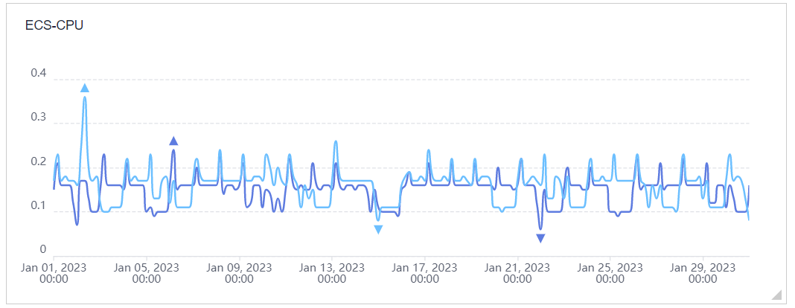

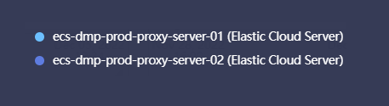



Production ECS CPU usage is below 4% and there is no heavy CPU usage in any of the servers.

There is a spike on Jan 2nd but it’s below 1% which is a normal behavior and that is settled down after some time.

**ECS CCE CPU Usage DMP Production**

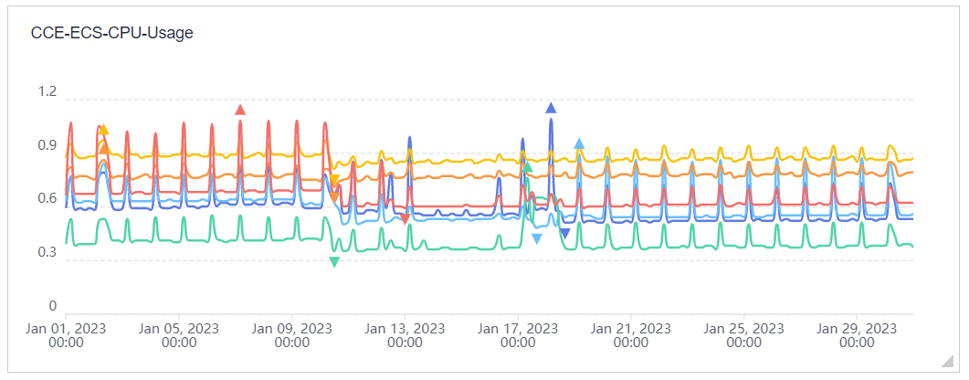

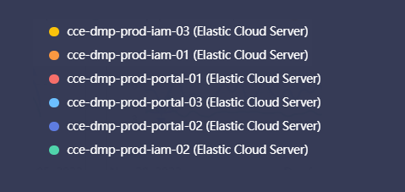



Production CPU usage is below 2% and there is no heavy CPU usage in any of the servers.

There is a spike in the graph that is less than 1% and Idle.

## RDS Usage

**RDS CPU, RAM and Disk Usage Production**

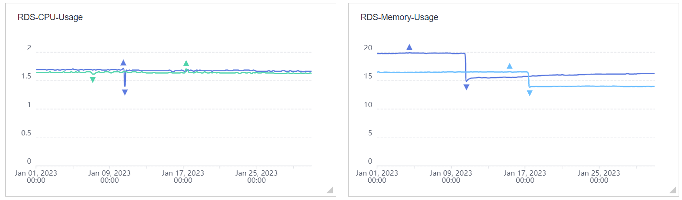

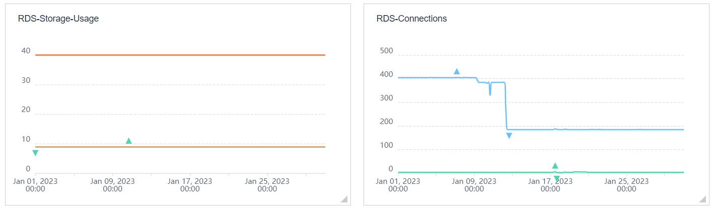

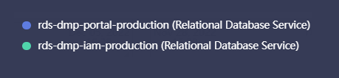

CPU and RAM usage in the production RDS is average. Resource utilization is effective from the infrastructure perspective, **RDS Disk usage** is remains unchanged at 8.9 GB out of 40 GB. However, **RDS Connections** decreased from averaging 400 to 184 counts. RDS Memory Utilization decreased from 20% to around 16% for the Month.

CSS Usage

**CSS CPU and Disk usage**

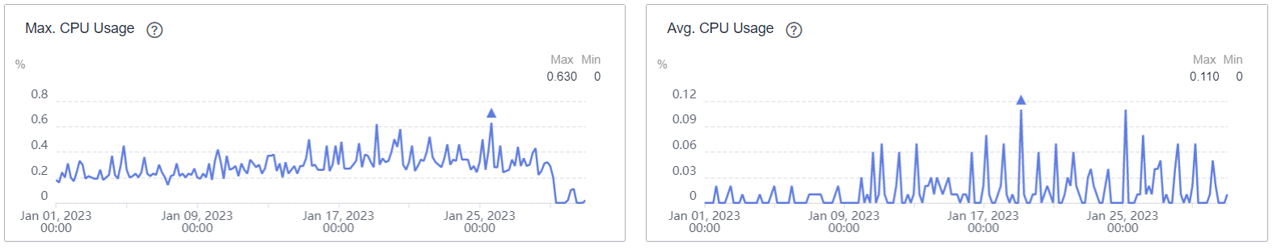

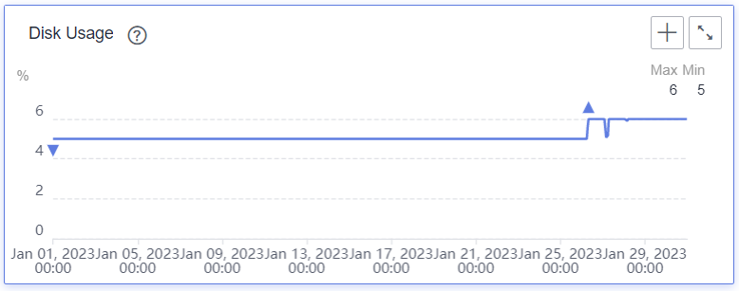

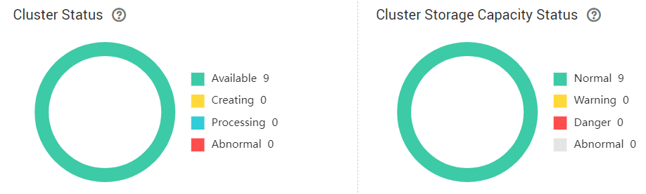

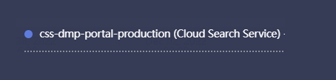



CSS CPU usage is unchanged below 1% and Disk usage is 6%,

Minimum available storage size is 73 GB and the cluster is healthy and available for the Month.

CCE Hosts

Production CCE Cluster- DMP (Portal and IAM)

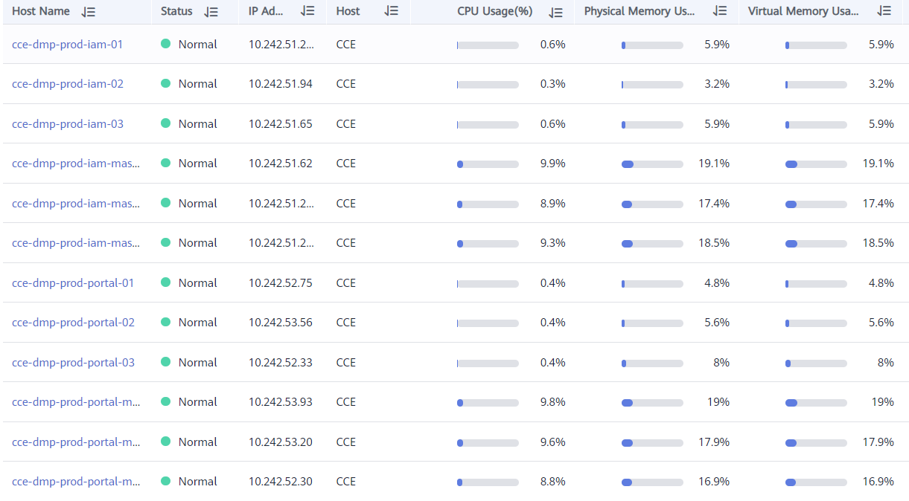

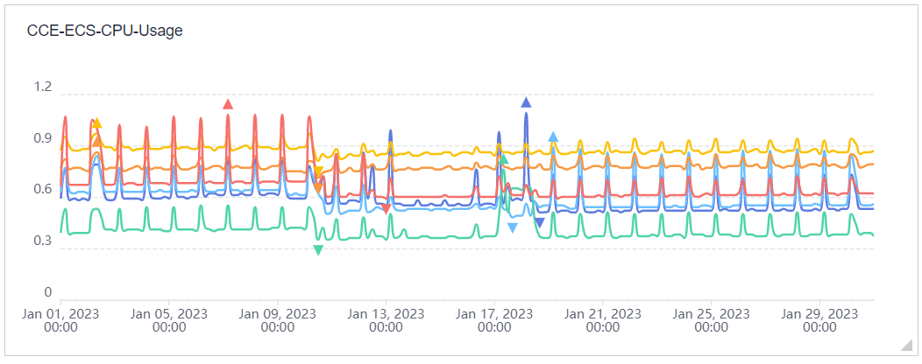



DMP-Prod CCE Cluster is healthy and the resource utilization is normal. CPU Utilization is less than 1% for the Month.

# Network bandwidth

**RDS Production**

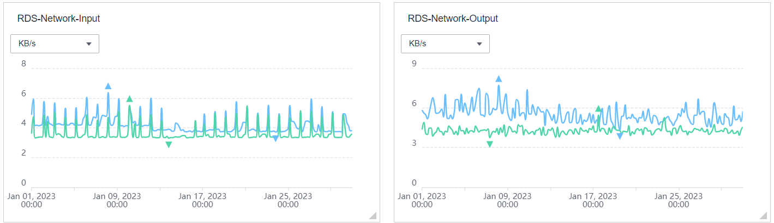



No heavy network usage during the past Month in the Production RDS environment.

# Alarms and Cloud Monitoring

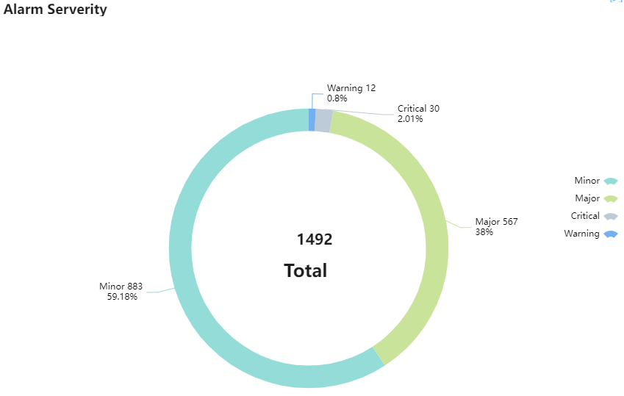

**GLOBAL ALARM TRENDS**

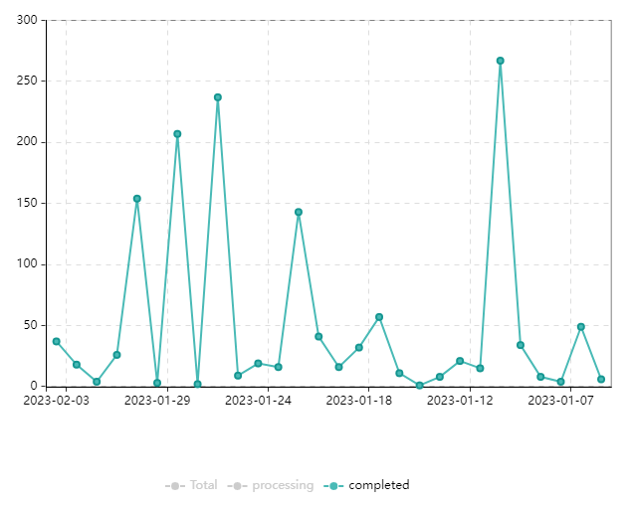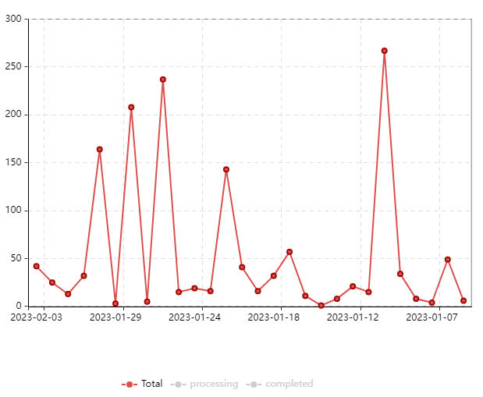

Alarm Objects Triggered

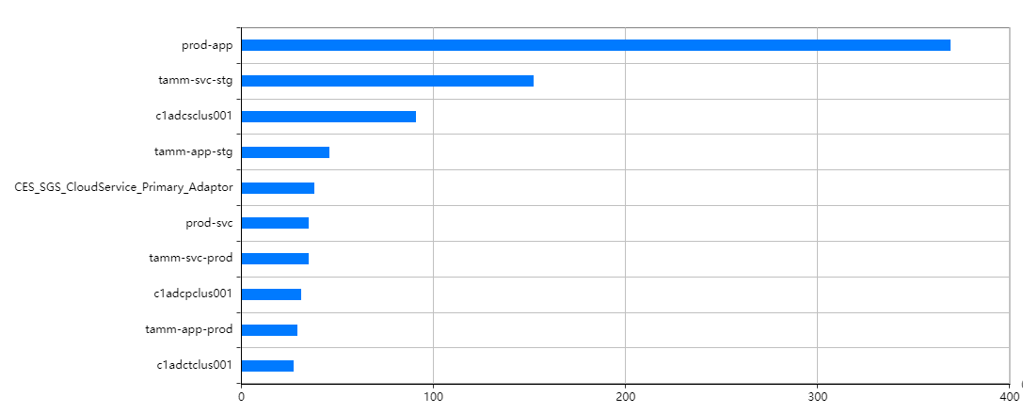

TOP 10 Objects Category Triggered

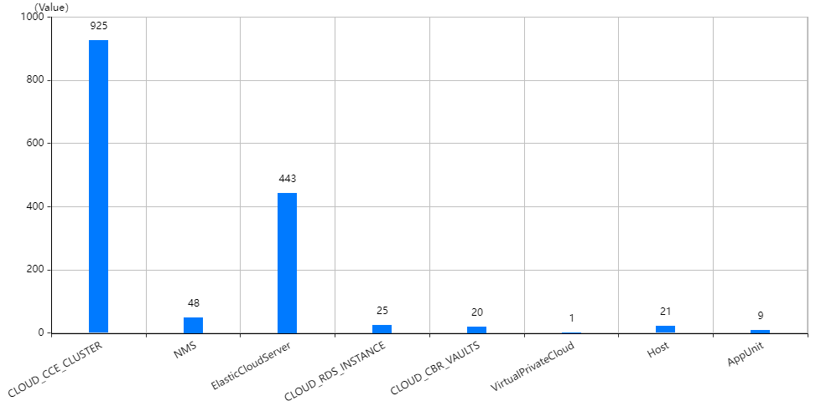

Prod-App with Category CCE triggered more alerts compared to other categories and majority of the tickets created were less severe and most incidents auto-resolved. Elastic Cloud Server category and 2nd highest triggers due to Memory, Storage and CPU Cloud-Eye thresholds been breached, Support resolved these issues without any downtime.

# Tickets

Tota **Critical Incidents** created the last 30 days are **0** Tickets ,(**0**)Tickets created during last 7days  
Total **High Incidents** created the last 30 days are **244** Tickets ,(**101**)Tickets created  during last 7days  
Total **Medium Incidents**created the last 30 days are **234**Tickets ,(**174**)Tickets created  during last 7days

## Number of Tickets by Priority

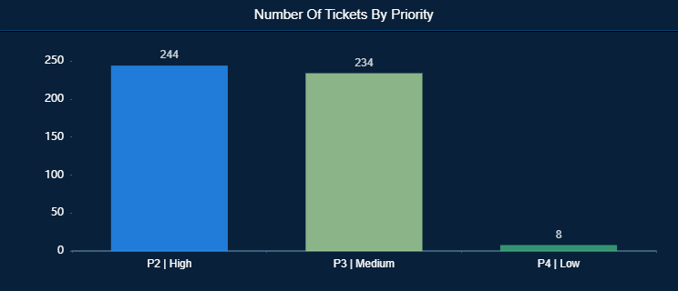

## Number of Tickets by Service Component

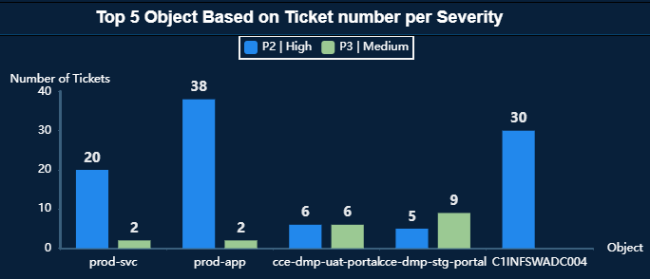

## Number of Tickets by Cloud Service

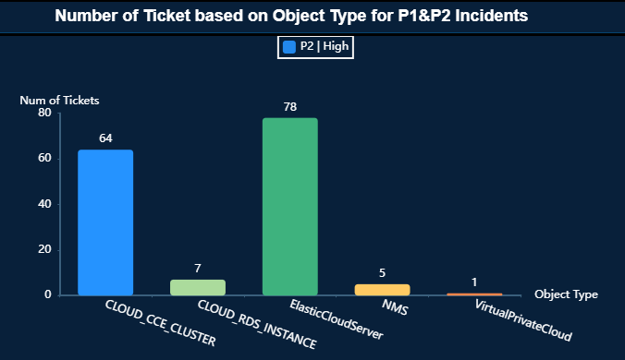

## ­­Number of Tickets by Type

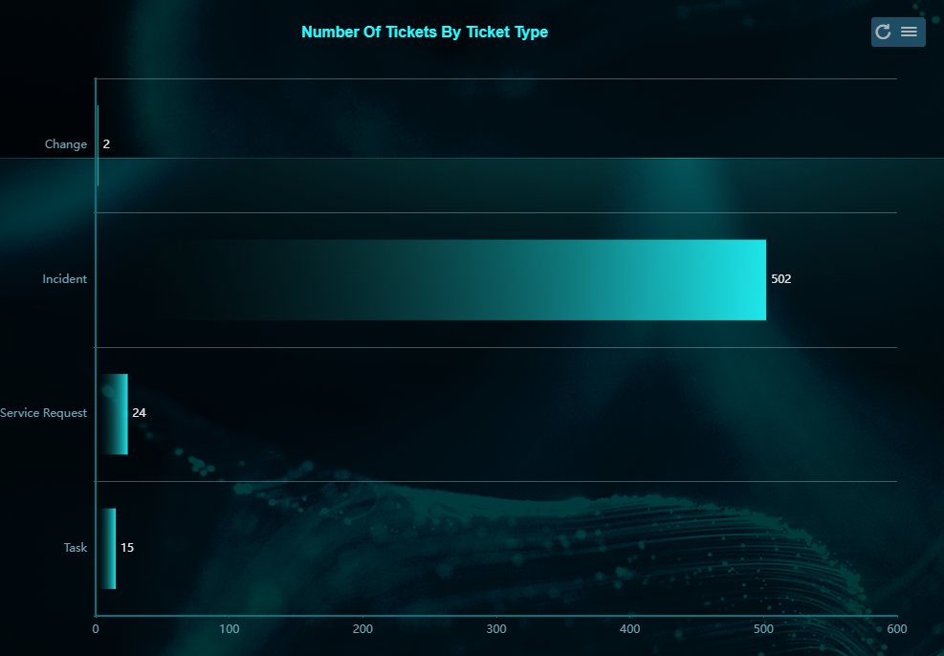

Prod-App with Category CCE triggered more alerts compared to other categories and majority of the tickets created were less severe and most incidents auto-resolved. Elastic Cloud Server category and 2nd highest triggers due to Memory, Storage and CPU Cloud-Eye thresholds been breached, Support resolved these issues without any downtime.

# Conclusion

## Highlights

* + All the cloud user access requests were provisioned by managed services after getting necessary business approvals from DEP.
  + Security patches have been applied to the environment according to the latest vulnerability scanning report and the resources were successfully patched.

Improvements

* N/A

## Blockers

* N/A



**Thank You**

